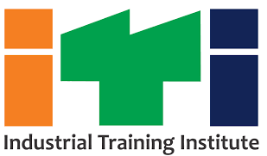
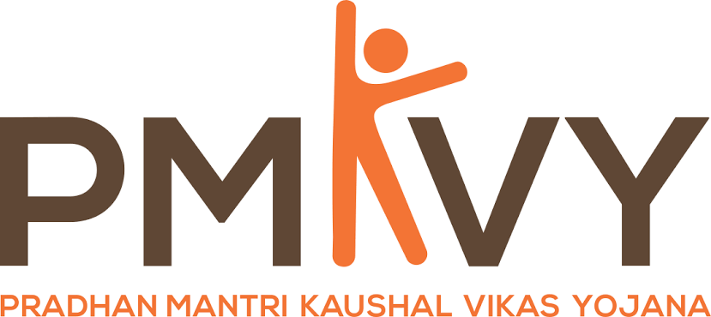
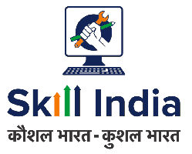
4.0

GRAB THE OPPORTUNITY

- Free Short Term Skill Training Courses for School Dropout, College Dropout, and Unemployed Youth at ITI Shopian.
- Short Term Training will be imparted in various Courses as mentioned below: -
- Tailoring
- Computer Operator / Desktop Publisher
- Nursery worker
- Low voltage electrician
- Front office associate
- Rooftop solar power installation
- Automotive sales Executive
- In addition, post placement support will be provided to students who complete Training.
- Globally Recognised Certificate of NSDC will be issued to pass out Students.

- For availing Benefits/Registration of Scheme Contact Below mentioned Contact No.’s.

- Visit our Website.
www.itishopian.org

Contact No:- 7006209771 / 7006310471

